Chapter 9, Solution 67.

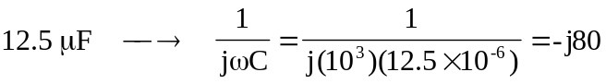

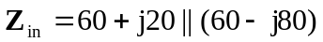
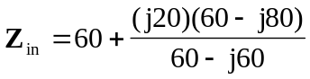

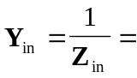 14.8-20.22 mS

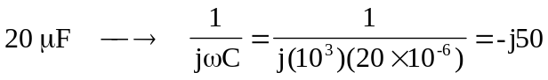
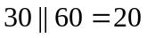

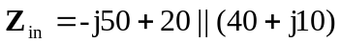
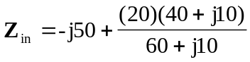= –j50 + 20(41.231∠14.036°)/(60.828∠9.462°)
= –j50 + (13.5566∠4.574° = –j50 + 13.51342 + j1.08109
= 13.51342 – j48.9189 = 50.751∠–74.56°

19.70474.56 mS = 5.246 + j18.993 mS

